

Single System
Junior Regional Performance Centres

Host application pack

In partnership with





MIDLANDS
REGION HOCKEY
ASSOCIATION



Content List

Section | Title | Page Number
1 | Introduction and background | 3 - 6
2 | Benefits of hosting a Junior Regional Performance Centre | 6
3 | Criteria for hosting a Junior Regional Performance Centre | 7
4 | Tender, timeline and application process | 8 - 9
Appendix 1: | Registration of interest form

1. Introduction & background

What is the Single System?

Hockey’s Single System is the development pathway enabling players, coaches and officials of all ages and abilities to reach their full potential. It is based on a set of principles that puts the participant at the centre of what we do and is based on scientific research that has been widely accepted by a large number of other major sports within England.

Why does hockey need a Single System?

Hockey in England has evolved over many years and has many historical boundaries, systems and competitions that make the current hockey landscape a complicated one. Currently, the pathway varies enormously, not only between boys and girls, but also from region to region and county to county. For example, a fourteen year old living in Exeter would have a different experience moving through the pathway to a similar player living in Hull. The purpose of the Single System is to make opportunities for participants equitable, transparent and consistent. It is to ensure that a suitable level of coaching and competition is offered for people at the appropriate stage of their development and to maximise the chance they have of fulfilling their potential whether that potential is as a club or international player, coach or official.

What are Junior Regional Performance Centres?

England Hockey and the 5 Regional Hockey Associations are working together to set up 12 Junior Regional Performance Centres (JRPCs) which will replace the existing inter regional programme where 7 boys regional teams and 5 girls regions currently train and then compete against one another.

The centres will provide coaching and competition at the level immediately below international representation as part of the pathway as shown in diagram 1.

There will be 12 JRPCs for U15/U16/U17/U18 boys and girls. The geographic locations for these centres have been agreed by the 5 Regional Hockey Associations as detailed in diagram 2. England Hockey and the Regional Hockey Associations are now seeking applications from hockey providers that are within a 45 minute drive time of these locations to be a facility host of JRPC activity and become a JRPC from summer 2009.

Talent selection into the JRPCs will be via Junior Academy Centres which are currently being set up in all Counties. Players aspiring to play international hockey will be identified from the JRPCs through a National Tournament.

Diagram 1
NATIONAL SQUAD
U16 + U18
JUNIOR REGIONAL PERFORMANCE CENTRE
U15, U16, U17, U18 only
12vcentres nationally
SCHOOL – CLUB LINK
Approx 400 nationally
JUNIOR DEVELOPMENT CENTRE
U12, U13, U14, U15, U16, U17 only
Approx 126 centres nationally
JUNIOR ACADEMY CENTRE
U13, U14, U15, U16, U17 only
Approx 48 centres nationally
JUNIOR CLUB
Approx 400 nationally
NATIONAL SQUADS
U21 + SENIOR
NATIONAL PERFORMANCE CENTRE
U19 - U23 + SENIOR
6 nationally
SENIOR REGIONAL PERFORMANCE CENTRE
U18, U19, U20, U21
Approx 20 nationally
SENIOR CLUB
Approx 1050 nationally
HE/FE – CLUB LINK
Approx 80 nationally
PLAYER PATHWAY U18
PLAYER PATHWAY 18+
CLUBS
Diagram 2 Table 1
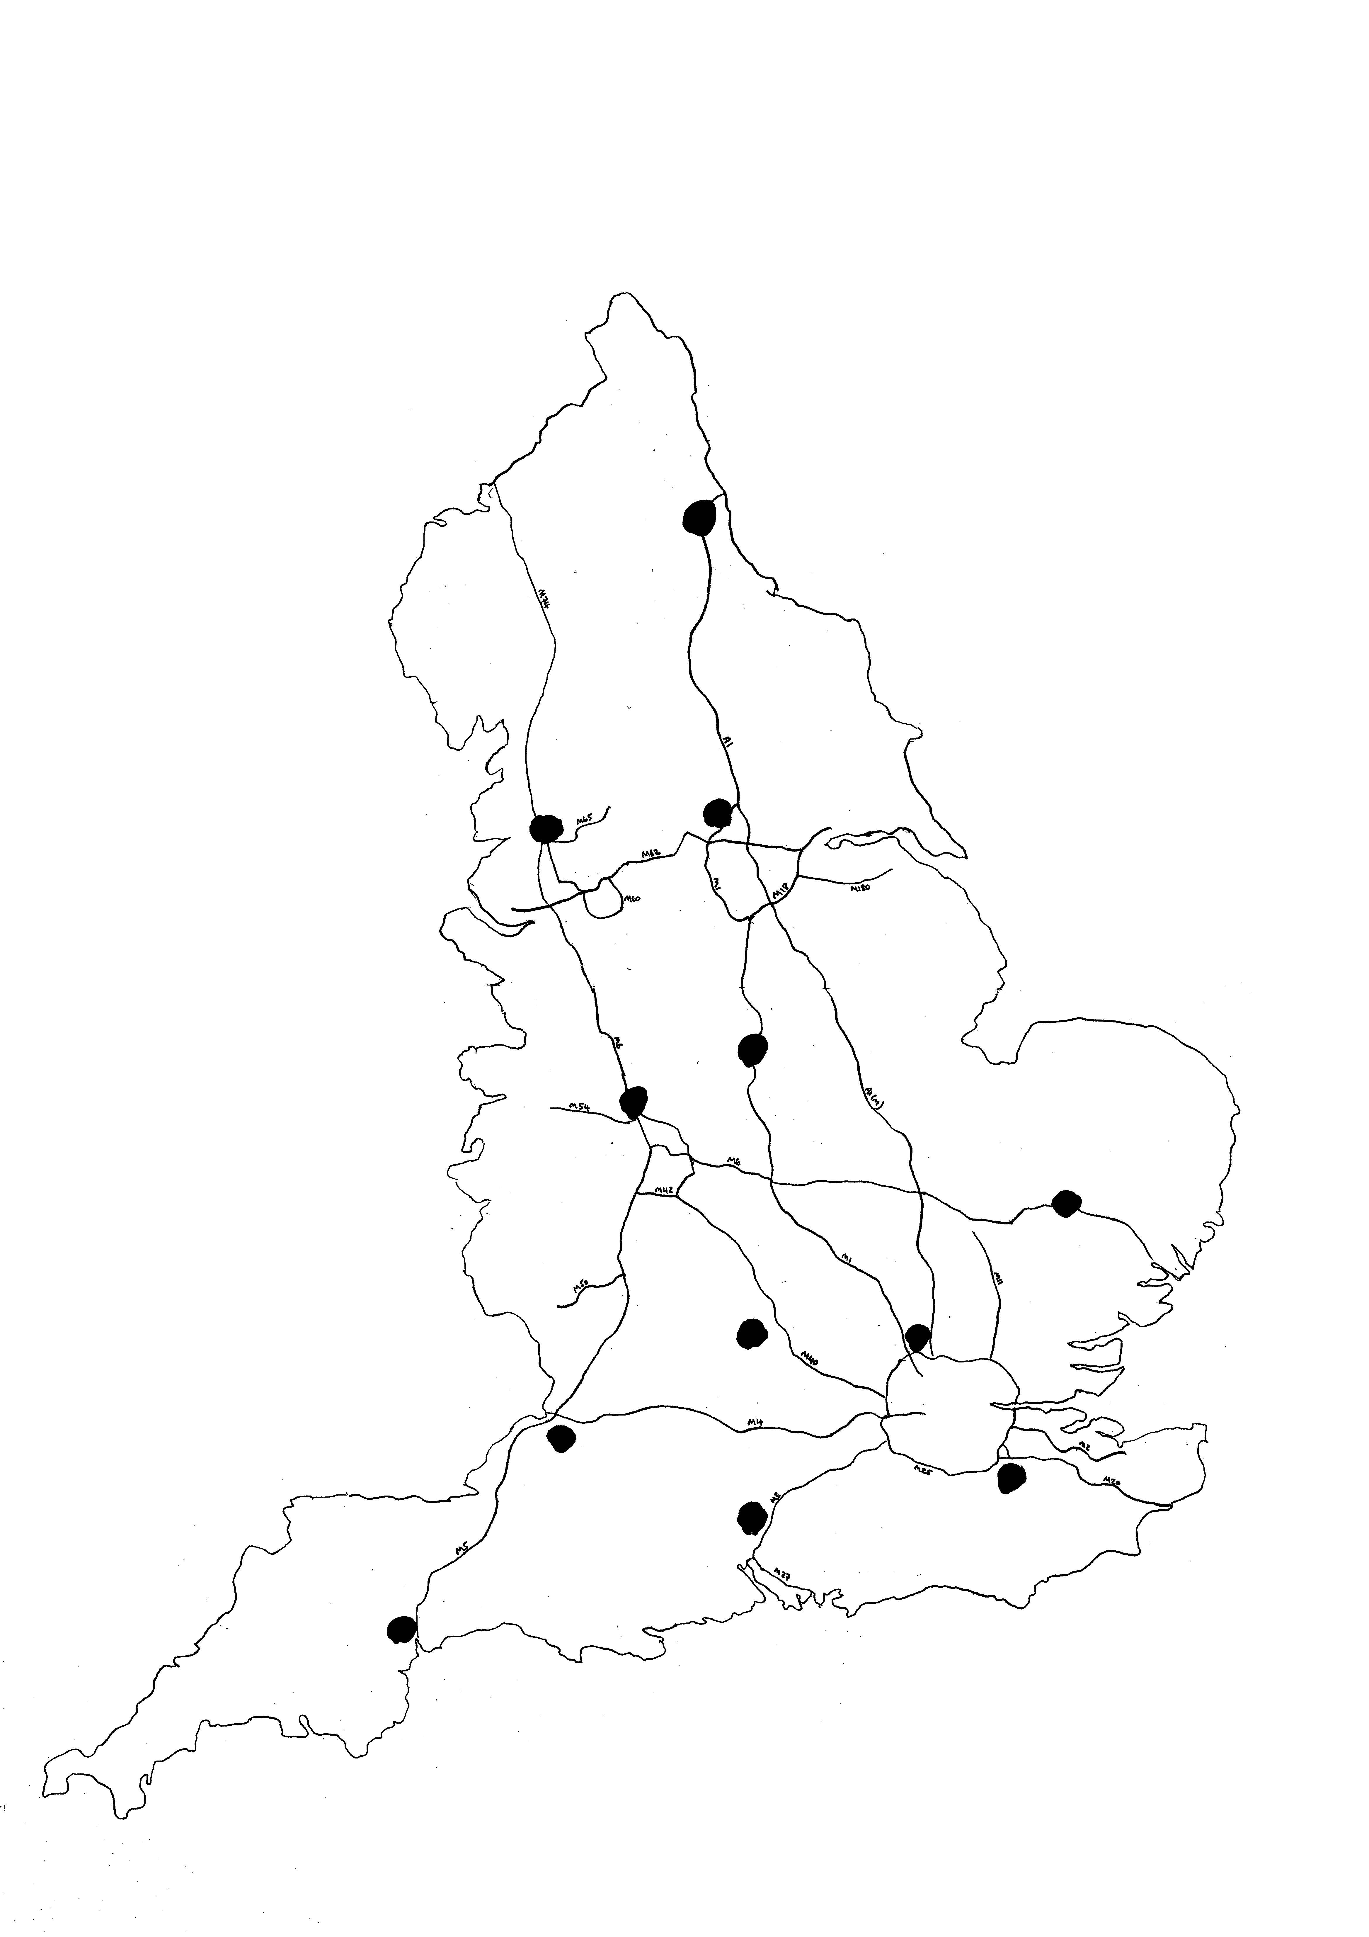
1
- Newcastle
- North Manchester
- Leeds
- Nottingham / Loughborough
- North Birmingham
- North Oxford
- Bury St Edmunds
- St Albans
- Oxted
- Winchester
- Bristol
- Exeter

What will the JRPCs offer?

JRPCs will offer coaching for boys and girls between July and October. See draft calendar (to be released August 1 2008). Coaching will lead to competition and new High Performance Camps (HiPACs).

Competition & High Performance Camps

Competitions - For U16s and U18s there will be two tiers of regional competition. In tier 1, the 12 JRPCs will compete in 4 clusters of 3 teams at the end of September. Regional Coaches and England Performance Coaches will provide the coaching, and the players with the most potential within each of these 4 clusters will be selected to represent that cluster to play in a national competition against the other three cluster teams in the tier 2 competition.
Tier 2 (U16 and U18)
Involving 4 representative squads of regional standard. One squad selected from each of the 4 Tier 1 clusters

Tier 1 (U16 and U18)
Involving 12 JRPC squads in cluster groups
4 clusters of 3 JRPC squads
2
1

The cluster groupings are indicated in Table 1on page 5 above

For U15s and U17s there will be 1 tier of competition the same as tier 1 for U16s and U18s. Players with potential from each of the 12 JRPCS competing in Tier 1 will be selected to attend HiPACs. These are new national camps where players will experience performance coaching, training, exposure to sports science methods on fitness and nutrition

All of the above will be part of a centralised calendar (to be released on August 1 2008) that will include 2 cycles in every hockey season one pre Christmas and one post Christmas. Each cycle will include a phase of preparation, a phase of competition and a phase of rest. When it is introduced for season 2009 / 10, all junior hockey will be working to the same centralised calendar which will show which activity should take priority and this will reduce conflict for young players. The JRPC activity will take place during cycle 1 only, between August and October each year.

As well as regular coaching sessions during the preparation phase from July to October, JRPCs may be involved in hosting competition between the cluster JRPCs. These competitions will be one day tournaments.

How will the JRPCS benefit the players?

Regular coaching from Regional Coaches and England appointed Centrally Contracted Coaches (CCCs) at the 12 JRPCs will expose more players to a higher level of coaching at an earlier stage in their development. By using the philosophy and style similar to that of the England National Age Group squads, progression for the athletes to the international environment will be improved. For those who do not move to the next level it will raise their game to higher levels helping them also reach their potential.

The Tier 1 competitive structure will provide many more players with increased competition closer to home while the Tier 2 national competition with 4 teams will replicate the format of junior international hockey.

The new HiPACs will provide positive experiences at an earlier age for more of our aspiring international athletes and expose them to high level training, coaching and sport science methods.

Very importantly, players will be continually assessed throughout the regional cycle so that selection to a National Age Group Squad is not based almost purely on performance at a single tournament as it is currently.

How will the changes benefit coaches, officials and volunteers?

Regional and England Performance Coaches will work together at the JPRCs, competitions and HiPACs and this will provide direct development for regional coaches aiding both the players and the coaches themselves.

England Hockey has recently appointed CCCs who will work with the Regional Coaches and be responsible for the coaching programme and its delivery at JRPCs.

Umpires, officials and volunteers will be able to gain valuable experience with the organisation and officiating of formal and informal competition that replicates international events.

The JRPCs will provide excellence in training facilities for approximately 20 players of each gender in each of the four age groups.

By March 2009, England Hockey and the 5 Regional Hockey Associations proposes to award 12 facilities the title of Junior Regional Performance Centre. It is envisaged that these Performance Centres will commence activity in summer 2009.

2. Benefits for Junior Regional Performance Centre hosts

- Raised profile and status of centre as one of only 12 England Hockey JRPCs
- Possible access to facility development funding. The Performance and Single System strategies will in future drive hockey’s facility development strategy. As such, and as part of England Hockey’s commitment, JRPCs will be well placed to benefit from National Governing Body support in facility development
- The Regional Hockey Association and England Hockey will fund and appoint coaches
- The Regional Hockey Association will deal with all player liaison
- Opportunity for the coaches based locally to work with the JRPC coaches on selected sessions which will aid the dissemination of high performance practice
- Priority site for hosting coach education and development programme

3. Junior Regional Performance Centre criteria

England Hockey request expressions of interest from applicants who can deliver the requested requirements outlined in this document for a 3-5 year fixed term.

Hockey Specific Requirements
ESSENTIAL
A minimum of one full sized floodlit hockey pitch (ideally plans for a second) - water based or sand dressed. The current performance surface is water based for international competition (guided by FIH rule, hockey’s international governing body). If there is not currently a sand dressed or water based facility then there needs to be in place a plan to upgrade to one of these surfaces.
ESSENTIAL
Priority bookings for all Sundays in draft centralised calendar (to be released on August 1 2008). Please note facility providers could submit a joint bid with another facility provider to provide all the required pitch time.
DESIRABLE
Access to an Indoor (hockey surface) training venue (equivalent size of 4 badminton courts). EH appreciate the high demand for such a facility and so access will be negotiated at relevant times - this facility need not be on site but could be within walking distance of site
DESIRABLE
Suitable (raised platform) video vantage point (s) with access to electricity points?

Generic Requirements
ESSENTIAL
Changing and showering facilities for girls and boys
ESSENTIAL
Conference room or classroom to seat 30 people theatre style
DESIRABLE
Gymnasium with cardiovascular equipment/free weights/resistance equipment/strength and agility equipment
DESIRABLE
Permanent safe storage area for kit to include balls, cones, bibs etc.

4. Tender, timeline and application process

Application to host a JRPC can be submitted by any hockey facility provider club, school, local authority, university etc via an open and transparent process.

A three stage application process is proposed.

Stage 1 - Initial expressions of interest (EOI) will be invited and considered by the selection panels.
Stage 2 - England Hockey and the Regional Hockey Associations will then nominate a number of applicants to make a full and detailed application for Junior Regional Performance Centre status.
Stage 3 - The selection panel will consider all applications; and invite applicants who are successful at stage two to deliver a presentation to the panel or visit the site.

JRPC Panels

There will be 5 selection panels, one in each region. Each panel will consist of up to 4 Regional Hockey Association representatives plus from England Hockey the Development Director or Performance Director (Sally Munday and David Faulkner respectively), National Manager Regional Network (Steve Floyd) and Regional Manager for that region. Each panel will be chaired by Steve Floyd.

Timeline

July 1st - September 30th 2008 | Adverts for tender/expressions of interest (EOI)
30th September 2008 | Expressions of interest (EOI) deadline
October 2008 | 5 x panel meet to review applications, shortlist developed
November 1st 2008 | Applicants invited for full tender
December 15th 2008 | Closing date for full tender
January 2009 | 5 x Panels meet re applications. Outcome; shortlist
February 2009 | Possible presentations to the panels and /or site visits
March 2009 | Panels x 5 meet for final selection.
March 31st 2009 | Announcement of Junior Regional Performance Centres
August 2009 | Junior Regional Performance Centres operational

*Expressions of interest shall be via the application form (Appendix 1) outlining the applicants current position to host the JRPC against the criteria or a timeline for achieving the criteria.

The following summarises the information to be provided with the initial expression of interest (EOI). More detailed information will be requested via the full application form;

- General facility provision
- Hockey specific facility provision and any plans to upgrade facilities
- Current hockey users of facility
- Costs of facility

If you have any enquiries regarding the JRPCs, please contact Steve Floyd, National Manager Regional Network, Tel 07966 305857 or e-mail steve.floyd@englandhockey.org

Appendix 1:

Junior Regional Performance Centre
Expression of Interest Form

This form is for applicants wishing to express an interest in hosting one of the England Hockey Junior Regional Performance Centres.

The document shall arrive for the attention of Steve Floyd, Junior Regional Performance Centre Tender, England Hockey, Bisham Abbey National Sports Centre, Marlow, Bucks, SL7 1RT, no later than 30th September 2008

This is an expression of interest (EOI) only, therefore we ask, if you have any extra details which you think will support your application, you keep it as brief as is possible at this stage. If you are short listed, England Hockey will request a full application to be made, you will then be able to give comprehensive explanation of any further details you feel may support your application.

Application on behalf of: | (i.e. Name of club, school, local authority, HE/ FE)
Application contact:
Address:
 |  | Post Code
Telephone contact:
Email:
Cluster/consortium
application:

England Hockey request the following criteria be met, or the applicant to be working towards meeting the criteria. Please place a tick in the relevant box, using the final column to detail any plans or work in progress which may support your application.

PART A  Hockey Specific Requirements | In Place | Not in Place | Working Towards  (to include estimated timescale for completion)
A minimum of one full sized floodlit hockey pitch (ideally plans for a second) - water or sand dressed. The current performance surface is water based for international competition (guided by FIH rule, hockey’s international governing body). If there is not currently a sand dressed or a water based facility then there needs to be in place to plan to upgrade to one of these surfaces.
Priority bookings for all Sundays as outlined on the centralised calendar (to be released on August 1 2008). Please note facility providers could submit a joint bid with another facility provider to provide all the required pitch time.
Suitable (raised platform) video vantage point (s)
Access to an indoor (hockey surface) training venue (equivalent size of 4 badminton courts). EH appreciates the high demand for such a facility and so access will be negotiated at relevant times - this facility need not be on site but could
be within walking distance of site
PART B  Generic Requirements | In Place | Not in place | Working Towards  (to include estimated timescale for completion)
Changing and showering facilities for girls and boys up to 30 people
Conference room or classroom to seat 30 people theatre style
Gymnasium with cardiovascular equipment/free weights/resistance equipment/Strength and Agility equipment

PART C

COSTS OF USING FACILITIES
Please detail below any costs that would be charged for use of any of the facilities

